Sessions fires former FBI deputy director
Sat Mar 17, 2018 02:31AM US
Politics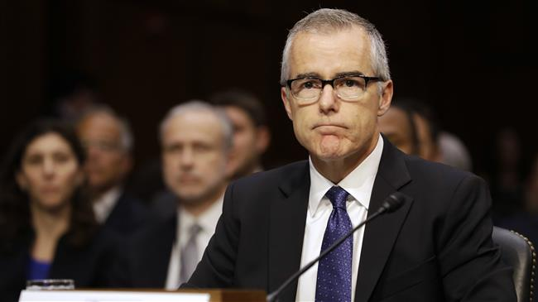 Former FBI Deputy Director Andrew McCabe (File photo)
US Attorney General Jeff Sessions has sacked Andrew McCabe, the FBI's former No. 2 official who played a leading role in the agency's investigations of Hillary Clinton and Russia's alleged interference in the 2016 US election.
“Pursuant to Department Order 1202, and based on the report of the Inspector General, the findings of the FBI Office of Professional Responsibility, and the recommendation of the Department’s senior career official, I have terminated the employment of Andrew McCabe effective immediately," Sessions said in a statement Friday night.
The dismissal of McCabe, who was repeatedly criticized by President Donald Trump, came at the recommendation of an internal FBI office that deals with disciplinary matters.
The dismissal recommendation was made on a finding from the Justice Department inspector general that McCabe was unforthcoming during the review.
The review pertains to an investigation into a decision he made in 2016 to allow FBI officials to answer reporters’ questions about an investigation into the Clinton Foundation.
Describing McCabe as a “bad actor, Press Secretary Sarah Huckabee Sanders said Thursday that the determination whether to fire him would be at Sessions’ discretion.
“We do think it is well documented that he has had some very troubling behavior and by most accounts a bad actor and should have some cause for concern,” she told reporters.
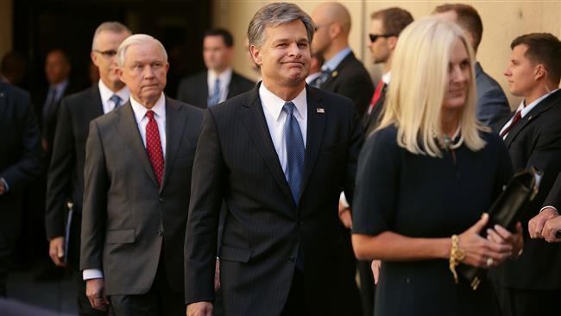
PressTV-FBI's No. 2 quits after Trump attack
FBI Deputy Director Andrew McCabe has stepped down after criticism by US President Donald Trump.
McCabe stepped down in January after criticism by Trump, but the official was going on "terminal leave," which meant he would be on payroll by the time he retires.
The president, who fired former FBI Director James Comey last year, has complained that McCabe is biased.
Like Comey, McCabe had been urged by Trump to drop the investigation into Russia’s alleged meddling in the 2016 presidential election.
"How can FBI Deputy Director Andrew McCabe, the man in charge, along with leakin’ James Comey, of the Phony Hillary Clinton investigation (including her 33,000 illegally deleted emails) be given $700,000 for wife’s campaign by Clinton Puppets during investigation?" Trump tweeted in December.

